The Role of IFD in Transformers: The Power Grid’s Guardian

Did you know that modern transformers are becoming smarter and can even detect issues on their own? Meet the IFD sensor (Internal Fault Detector)—a small yet mighty device that plays a huge role in keeping transformers safe and efficient. Let’s dive into the world of IFDs and see how this “guardian” works!

What is an IFD Sensor?
In simple terms, an IFD sensor is a small device installed inside transformers to detect internal faults in real-time, such as overheating, gas accumulation, and electrical discharges. Think of it as the “eyes and ears” of the transformer, continuously monitoring for any fault signals that might go unnoticed by human operators.

Why Do Transformers Need IFD?
Without an IFD, internal issues could go undetected until it’s too late, causing damage and possibly leading to transformer failure. With an IFD sensor, the system can detect problems early and raise an alarm, preventing minor issues from becoming major disasters. Here’s why IFDs are so important:
- Real-Time Monitoring: Constantly checks the internal conditions of the transformer and alerts the operators to abnormalities.
- Enhanced Safety: Detects potential dangers early, reducing the risk of sudden failures and blackouts.
- Prolongs Equipment Life: Early fault detection helps reduce repair costs and extends the transformer’s lifespan.

How Does the IFD Sensor Work?
You might wonder, how does this tiny sensor work inside a huge transformer? It’s actually quite simple! Internal faults in transformers often cause changes in physical properties, like increased gas levels or rising oil temperatures. The IFD sensor monitors these parameters and identifies potential issues. When something goes wrong, it sends out a warning, prompting the power company to take action.

IFD: The Silent Hero in Action
With an IFD sensor, a transformer becomes equipped with a “super sensing system.” Here’s what it can do:
- Early Prevention: Detects overheating or gas build-up before it leads to catastrophic failure.
- Prevent Blackouts: Helps avoid large-scale outages by ensuring timely maintenance.
- Lower Maintenance Costs: By spotting problems early, it reduces the need for emergency repairs.

Conclusion
While the IFD sensor may be small, it plays a crucial role in the safe and efficient operation of modern transformers. It helps safeguard the power grid, prolong transformer life, and prevent costly damage.
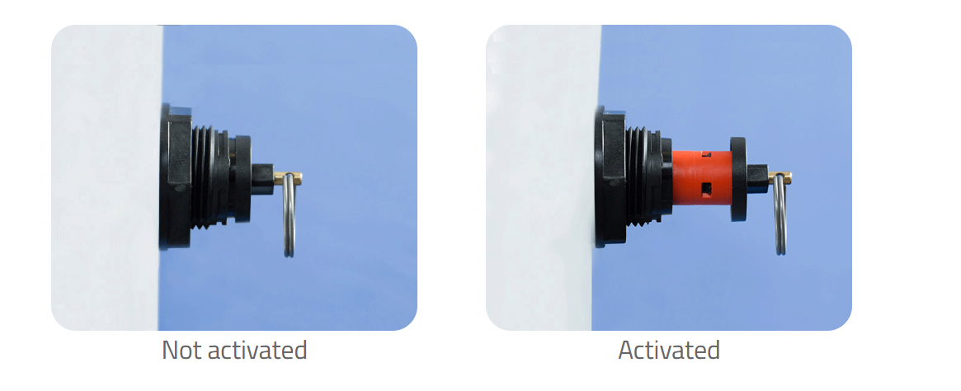

**IFD在变压器中的作用：电网的守护者**

你知道吗？现代变压器正变得越来越智能，甚至可以自行检测问题！让我们来认识一下IFD传感器（内部故障检测器）——这个虽小但强大的设备，在确保变压器安全高效运行方面发挥着巨大作用。今天，我们将深入探索IFD的世界，看看这位“守护者”是如何工作的！

**什么是IFD传感器？**
简单来说，IFD传感器是一种安装在变压器内部的小型设备，用于实时检测内部故障，例如过热、气体积累和放电。可以把它想象成变压器的“眼睛和耳朵”，持续监控任何可能被操作人员忽视的故障信号。

**为什么变压器需要IFD？**
如果没有IFD，内部问题可能会在无法挽回时才被发现，导致损坏甚至变压器故障。而有了IFD传感器，系统可以及早发现问题并发出警报，防止小问题演变成大灾难。以下是IFD如此重要的原因：
1. **实时监控**：持续检查变压器的内部状态，并在出现异常时提醒操作人员。
2. **增强安全性**：及早发现潜在危险，降低突发故障和停电的风险。
3. **延长设备寿命**：早期故障检测有助于降低维修成本并延长变压器的使用寿命。

**IFD传感器是如何工作的？**
你可能会好奇，这个小小的传感器是如何在巨大的变压器内部工作的？其实很简单！变压器内部故障通常会导致物理特性的变化，例如气体水平升高或油温上升。IFD传感器监控这些参数并识别潜在问题。当出现异常时，它会发出警告，促使电力公司采取行动。

**IFD：默默行动的英雄**
有了IFD传感器，变压器就配备了一个“超级感应系统”。以下是它的功能：
1. **早期预防**：在过热或气体积累导致灾难性故障之前检测到问题。
2. **防止停电**：通过确保及时维护，帮助避免大规模停电。
3. **降低维护成本**：通过及早发现问题，减少紧急维修的需求。

**结论**
虽然IFD传感器可能很小，但它在现代变压器的安全高效运行中起着至关重要的作用。它有助于保护电网、延长变压器寿命并防止昂贵的损坏。

